**Step 1: Drawing Basic Shapes With Python Turtle**

1. Create an new Repl by selecting the **“Python with Turtle”** language / environment.

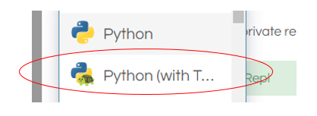

1. Begin all of your turtle programs with the following code to create a “pen”:

import turtle

myPen = turtle.Turtle()

1. Review the following chart for a list of Turtle commands.

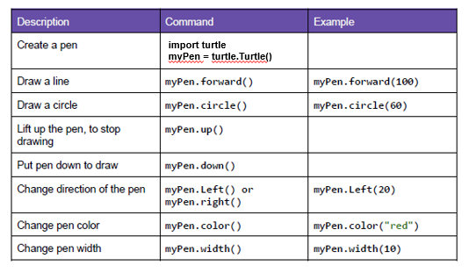

1. Use the following program to draw a red square.

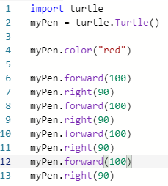

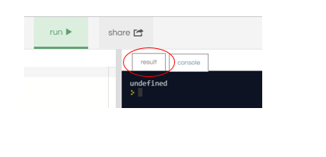

1. Switch to the “Result” window to see the square.
2. Create a program to draw any one of the shapes “b”, ”d”, or “e” shown in the figures below.   
   Provide a listing of your program code.

D

import turtle

myPen = turtle.Turtle()

myPen.color("orange")

myPen.right(45)

myPen.forward(150)

myPen.right(180)

myPen.up()

myPen.forward(75)

myPen.right(90)

myPen.forward(75)

myPen.down()

myPen.right(180)

myPen.forward(150)

1. Create a program to draw any one of the shapes “c”, or “f” shown in the figures below.   
   Provide a listing of your program code.

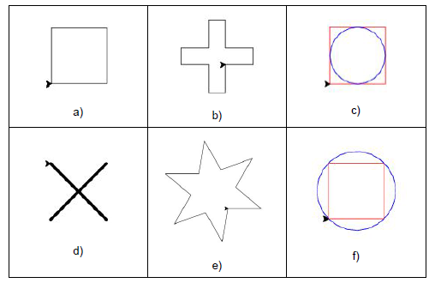

C

import turtle

myPen = turtle.Turtle()

myPen.color("sky blue")

myPen.forward(100)

myPen.right(90)

myPen.forward(100)

myPen.right(90)

myPen.forward(100)

myPen.right(90)

myPen.forward(100)

myPen.right(90)

myPen.up()

myPen.forward(50)

myPen.down()

myPen.color("red")

myPen.right(180)

myPen.circle(50)

**Step 2: Christmas / Winter Theme Card**

1. Use your creativity to create a card design using Turtle.
   1. The design must have multiple figures.
   2. The design must have at least two different patterns.
   3. You may repeat patterns.
   4. Provide a listing of your program code.
   5. Provide an image of your program result.